**Lesson 9 Demo 5**

**Understanding Application Troubleshooting**



Steps to be followed:

1. Troubleshooting Application

**Step 1: Troubleshooting Application**

* 1. Find pods in the cluster using the following command:

***kubectl get pods -n test***

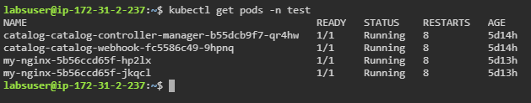

* 1. Describe any desired pod by using the below command:

***kubectl describe pod <name> -n test***

